1. Configure CloudWatch logs: Configure CloudWatch logs to capture logs from your AWS resources, such as EC2 instances and Lambda functions.  
   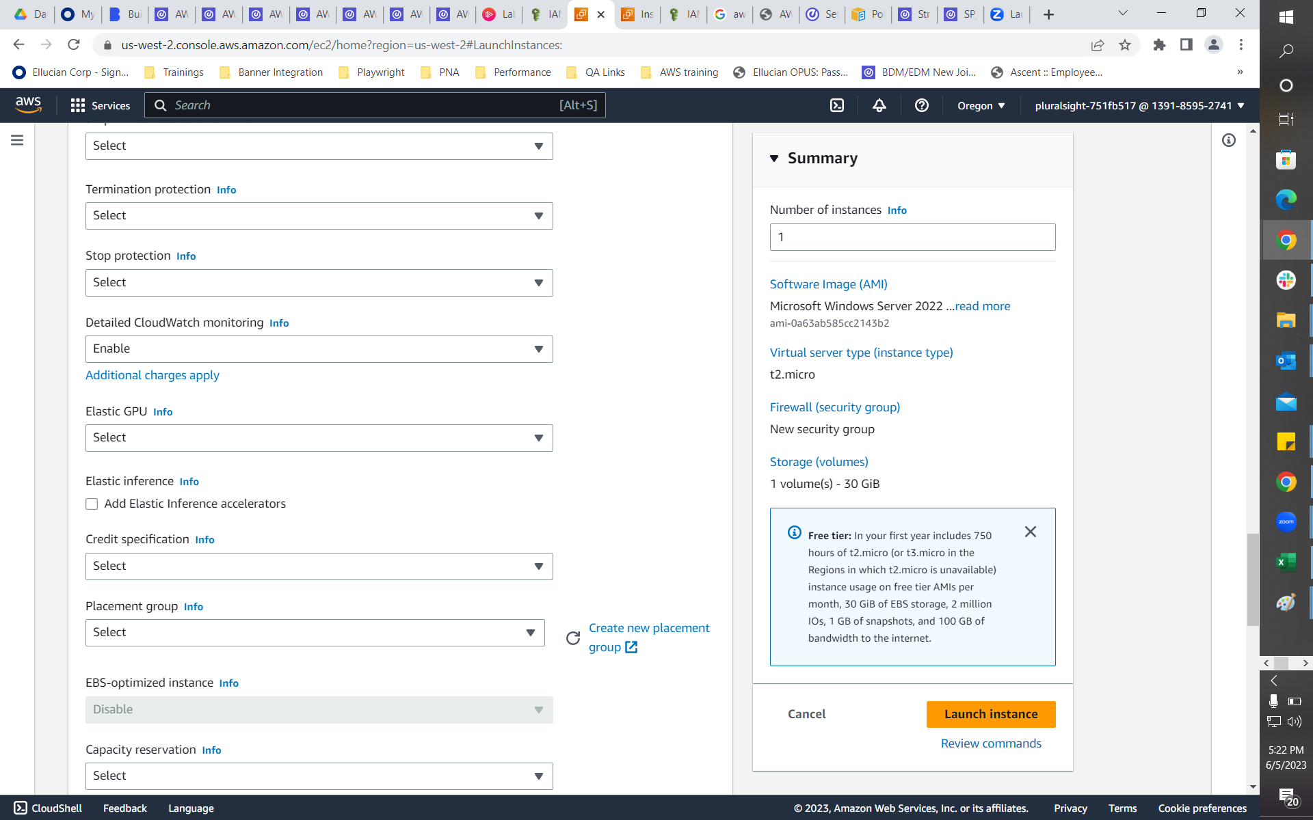  
     
   A screenshot of a computer

   Description automatically generated  
     
   A screenshot of a computer

   Description automatically generated  
     
   A screenshot of a computer

   Description automatically generated  
     
   A screenshot of a computer

   Description automatically generated
2. Monitor billing and cost with CloudWatch: Use CloudWatch to monitor your AWS billing and cost, and create alerts when certain thresholds are reached.
3. Create CloudWatch alarms for S3 buckets: Set up CloudWatch alarms to notify you when S3 buckets reach certain thresholds, such as when the number of objects in a bucket exceeds a certain limit or when the amount of data stored in a bucket reaches a certain size.
4. Use CloudWatch to monitor EC2 instances: Set up CloudWatch to monitor the performance of your EC2 instances, such as CPU utilization, memory usage, network traffic, and disk I/O.
5. Monitor Lambda function performance with CloudWatch: Use CloudWatch to monitor the performance of your Lambda functions, such as memory usage, duration, and error rates.